Lab 2: Enhancing a Dashboard and Adding Interactivity

© 2024 Amazon Web Services, Inc. or its affiliates. All rights reserved. This work may not be reproduced or redistributed, in whole or in part, without prior written permission from Amazon Web Services, Inc. Commercial copying, lending, or selling is prohibited. All trademarks are the property of their owners.

Note: Do not include any personal, identifying, or confidential information into the lab environment. Information entered may be visible to others.

Corrections, feedback, or other questions? Contact us at [*AWS Training and Certification*](https://support.aws.amazon.com/#/contacts/aws-training).

**Lab overview**

You have created your first Amazon QuickSight dashboard and presented your findings to the board of AnyCompany Software. Now, you want to enhance the look and feel of the dashboard and add interactivity as you expand your analysis for the next quarterly report.

For example, you want to give your readers the ability to take action directly from the dashboard. You can do this by adding custom business-specific filter actions and visuals that focus on AnyCompany Software’s sales per region and regional growth. You also want to explore the URL actions in QuickSight, linking your dashboard content to relevant web and internal company content.

In this lab, you use QuickSight to establish and apply a theme, create new sheets, customize insights, develop relevant filter actions, and implement URL actions.

OBJECTIVES

By the end of this lab, you will be able to do the following:

* Create additional sheets for drilling down into data.
* Establish standardized themes for your organization.
* Customize visuals and optimize dashboard layout settings.
* Develop meaningful filter actions that simplify dashboard results.
* Set up URL actions that link table results to web results.

DURATION

This lab requires approximately *60* minutes to complete.

ICON KEY

Various icons are used throughout this lab to call attention to different types of instructions and notes. The following list explains the purpose for each icon:

* **Expected output:** A sample output that you can use to verify the output of a command or edited file.
* **Note:** A hint, tip, or important guidance.
* **Learn more:** Where to find more information.
* **Consider:** A moment to pause to consider how you might apply a concept in your own environment or to initiate a conversation about the topic at hand.
* **Refresh:** A time when you might need to refresh a web browser page or list to show new information.
* **Hint:** A hint to a question or challenge.
* **Answer:** An answer to a question or challenge.
* **Task complete:** A conclusion or summary point in the lab.

**Start lab**

1. To launch the lab, at the top of the page, choose Start lab.

**Caution:** You must wait for the provisioned AWS services to be ready before you can continue.

1. To open the lab, choose Open Console.

You are automatically signed in to the AWS Management Console in a new web browser tab.

**WARNING:** **Do not change the Region unless instructed.**

COMMON SIGN-IN ERRORS

**Error: You must first sign out**

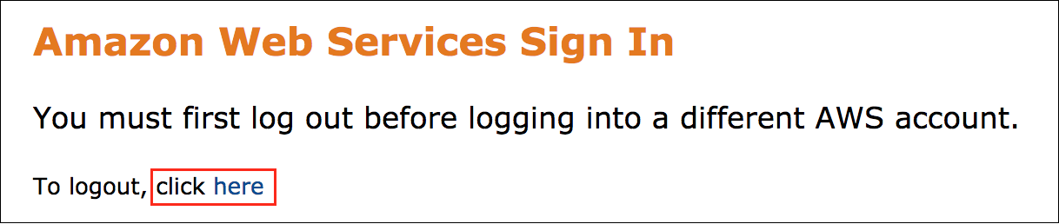

If you see the message, **You must first log out before logging into a different AWS account:**

* Choose the **click here** link.
* Close your **Amazon Web Services Sign In** web browser tab and return to your initial lab page.
* Choose Open Console again.

**Error: Choosing Start Lab has no effect**

In some cases, certain pop-up or script blocker web browser extensions might prevent the **Start Lab** button from working as intended. If you experience an issue starting the lab:

* Add the lab domain name to your pop-up or script blocker’s allow list or turn it off.
* Refresh the page and try again.

AWS SERVICES NOT USED IN THIS LAB

AWS service capabilities used in this lab are limited to what the lab requires. Expect errors when accessing other services or performing actions beyond those provided in this lab guide.

**Task 1: Establish and apply a theme**

As you improve your sales dashboard in Amazon QuickSight, you want to make sure that the theme is customized to AnyCompany Software’s branding. You use the custom theming options in QuickSight to create a standard AnyCompany Software theme.

In this task, you choose a default theme. You then make adjustments to that theme, matching AnyCompany Software’s brand color and font schemes.

TASK 1.1: EXPLORE THE DEFAULT STARTER THEMES

Choose a default theme for your dashboard. QuickSight offers three themes by default and provides many tools to help you customize themes.

1. At the top of the **AWS Management Console**, in the search bar, search for and choose

.

1. From the **Analyses** page, choose **quicksight-lab-2**.
2. In the navigation pane at the top of the page, choose **Edit** and choose **Themes**.
3. To expand the theme options, choose **Starter themes** if it is not already expanded.
4. Choose **Seaside** by selecting the color row.

**Expected output:** Your dashboard theme is now set to Seaside.

TASK 1.2: CREATE A CUSTOMIZED THEME

AnyCompany Software’s default font is *Inter* and their color scheme uses the hex color *#0ea7af*. To align with branding standards, change the theme font and color.

1. Next to the **Seaside** theme, choose the ellipsis icon, and then choose **Save as**.
2. For **Theme name**, enter

.

1. In the **Accent** section, select the color box next to the default hex color.
2. Choose **Custom color**.
3. In the **HEX** section, clear the current value and enter

.

1. Choose **Apply**.
2. In the **Font** section, choose **Amazon Ember** and select **Inter**.
3. In the left navigation pane, choose **Data**.
4. In the **Data colors** section, choose the grey **+** icon.
5. Under **Recent custom colors**, choose the HEX color

 or choose **Custom color** if that does not appear.

1. In the **HEX** section, clear the current value and enter

.

1. Choose **Apply**.
2. Select the color box you just added and drag it to the front of the color list.

Your primary data color changed from the default color to your new theme color. You can add or remove any of the colors from the **Data colors** section.

1. In the left navigation pane, choose **Layout**.
2. To add space between your visualizations, choose the **Margin** and **Gutter** options if they are not already selected.

**Consider:** How would you use custom themes in your organization to help standardize dashboards and align them with your company branding? Take a moment to explore the rest of the theme options.

1. In the top menu bar, choose **Save**.
2. In the **Themes** section, choose **AnyCompany_Software_Theme** by selecting the color row.

* **Task complete:** You have completed **Task 1** by aligning the dashboard theme with the company’s brand standards. You applied a default theme and edited the font and colors based on the company’s request.

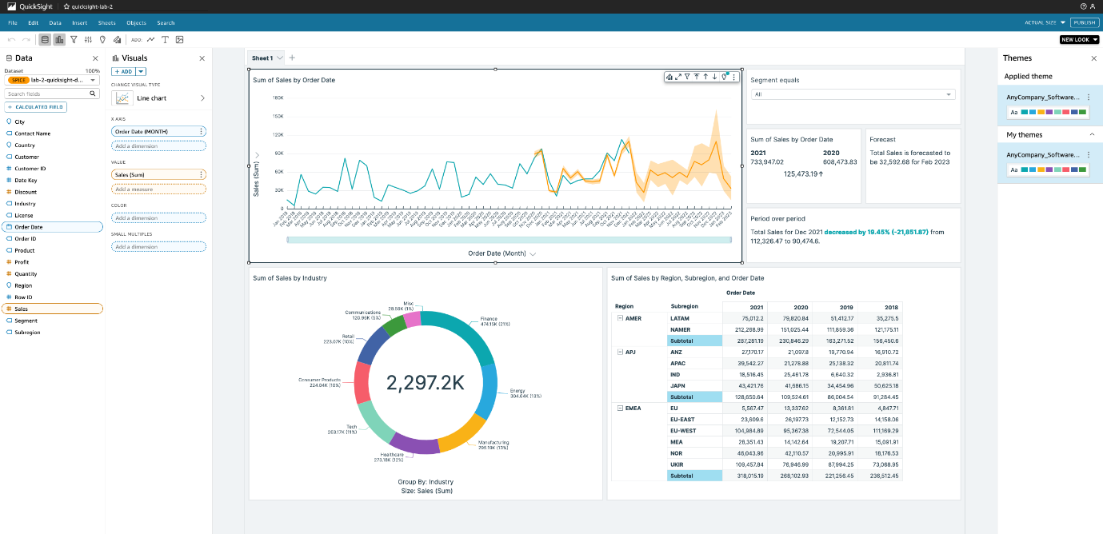

*Image description: The previous image shows the dashboard with new template colors*.

**Task 2: Adjust the dashboard formatting**

Now that your theme is created, you want to format the dashboard data with the right format, decimal places, and units to simplify the visualizations and remove unnecessary items from the dashboard.

In this task, you change the formatting for the sales and discount fields.

TASK 2.1: CHANGE THE FORMAT FOR A VALUE

Change the discount format to *percent* and the sales format to *currency*.

1. In the **Fields list** pane, hover over **Discount** and choose the ellipsis icon.
2. Choose **Show as: Number**, and then choose **Percent**.
3. In the **Fields list** pane, hover over **Sales** and choose the ellipsis icon.
4. Choose **Show as: Number**, and then choose **Currency**.

**Expected output:** All of the visualizations using the sales field now show sales in dollars.

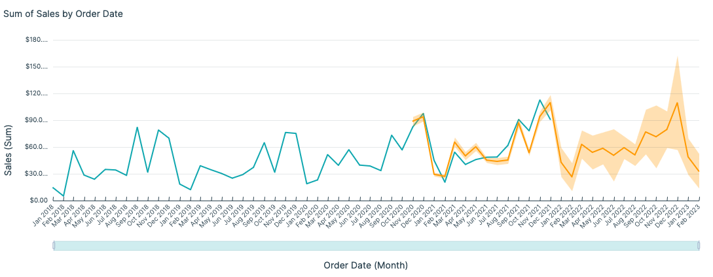

*Image description: The previous image shows the line graph of sales over time displaying the dollars as the unit of measure*.

**Learn more:** When you load data into QuickSight through SPICE, QuickSight automatically selects a data type. Based on the data type, the QuickSight dashboard editor presents several formats when you begin working with the fields. For more information about data types supported in QuickSight, see [Supported Data Types from Other Data Sources](https://docs.aws.amazon.com/quicksight/latest/user/supported-data-types.html) in the *Amazon QuickSight User Guide*.

TASK 2.2: CHANGE THE DECIMAL PLACES FOR A VALUE

Set the sales field decimal places to *0* using the advanced formatting options.

1. Choose the **Sum of Sales by Order Date** visualization if it is not already selected.
2. In the **Fields list** pane, hover over **Sales** and choose the ellipsis icon.
3. Choose **Format: $1,234.57**, and then choose **More formatting options…**.
4. In the **Format data** pane, choose **Decimal Places** to expand it.
5. In the **Decimal Places** field, change

 to

.

**Expected output:** All of the visualizations using the sales field now show sales with a rounded dollar amount.

**Note:** While you can make adjustments to many of the field settings without navigating to the **Format data** section, this section gives you access to fine-tuned control. For example, you can choose the preferred currency symbol, set how to format negative values, and decide what to show when there are null values.

**Task complete:** You have completed **Task 2** by adjusting your dashboard formatting. You edited the default formats for two values and changed the decimal places shown for the **Sales** field.

**Task 3: Add a map visualization**

Your dataset contains location data for AnyCompany Software’s sales. You want to create a map to show the magnitude of sales by region in an interactive visual for the next quarterly meeting. Readers can then drill into sales figures by location.

In this task, you create a map visualization based on location data and sales.

1. In the top menu bar, choose **Insert**.
2. Choose **Add visual**.
3. In the **Visuals** pane, find and choose the **Points on map** icon.
4. In the **Fields list** pane, choose **Country** and **Sales**.

**Expected output:** A map visualization appears with sales represented by the size of the circles on each country.

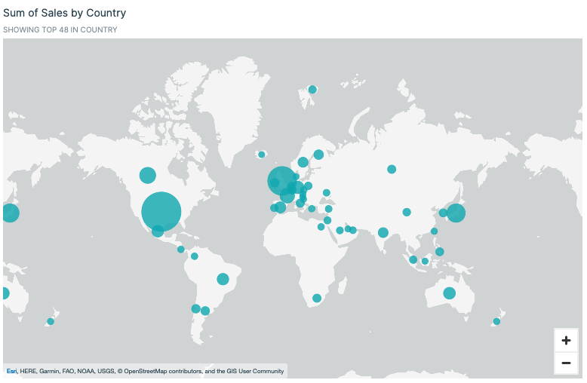

*Image description: In the previous image, the map visualization is shown*.

**Task complete:** You have completed **Task 3** by adding a map visualization. You used the country geospatial field and the sales field to show the sum of sales by country.

**Task 4: Create a new sheet and add conditional formatting**

After the board meeting, the product managers request the ability to drill down into the orders. The product managers want to fine-tune some of their sales strategies this year, focusing on reducing the use of deep discounts to complete a sale. From the high-level summary dashboard, the product managers want to see the results in a table on another page so they can dig into the largest orders and their discounts by country, customer, and industry.

In this task, you create a detailed table in a new sheet. You then customize the table to highlight data by using conditional formatting.

TASK 4.1: CREATE A NEW SHEET

Create a new sheet and rename it.

1. In the dashboard workspace, above the main visuals, choose the **Sheet 1** tab, and then enter

 to rename it.

1. To create a new sheet, choose the **+** next to the **Summary** tab.
2. Verify that **Interactive sheet** is selected, and then choose **+ ADD**.
3. Choose the **Sheet 2** tab, and then enter

 to rename it.

**Expected output:** You now have two tabs, one for the summary dashboard and one for the details table.

TASK 4.2: ADD A DETAILED TABLE

Add a detailed table in the new sheet and add the relevant fields.

1. On the **Details** sheet, choose the AutoGraph visualization.
2. In the **Visuals** pane, find and choose the **Table** icon.
3. In the **Fields list** section, choose **Order ID**, **Order Date**, **Contact Name**, **Country**, **Customer**, **Industry**, **Product**, **Discount**, and **Sales**.
4. Resize the visual so that it fills the **Details** sheet.

**Note:** You can resize the visualization by selecting and dragging any of the white squares at the corners or edges of the visualization.

1. Under **Value**, next to **Discount**, choose the ellipsis icon.
2. To change the aggregation to an average, hover over **Aggregate: Sum** and choose **Average**.
3. In the **Visuals** pane, next to **Sales**, choose the ellipsis icon.
4. To put the largest orders at the top of the table, choose the **Sort order** option and choose **Descending**.
5. In the visualization menu on the right of your details table, choose the **Format visual** pencil icon to open the **Properties** pane.

**Note:** You might need to select the table to show the visualization menu on the right of your details table.

1. In the **Visual** pane, choose **Display Settings**, and then choose the paint brush icon next to **Edit title**.
2. In the text box that shows *Default*, enter

.

1. Choose **Save**.

**Expected output:** You now have a detailed order table on a new sheet that product managers can use to see the largest orders and the details for each of those orders.

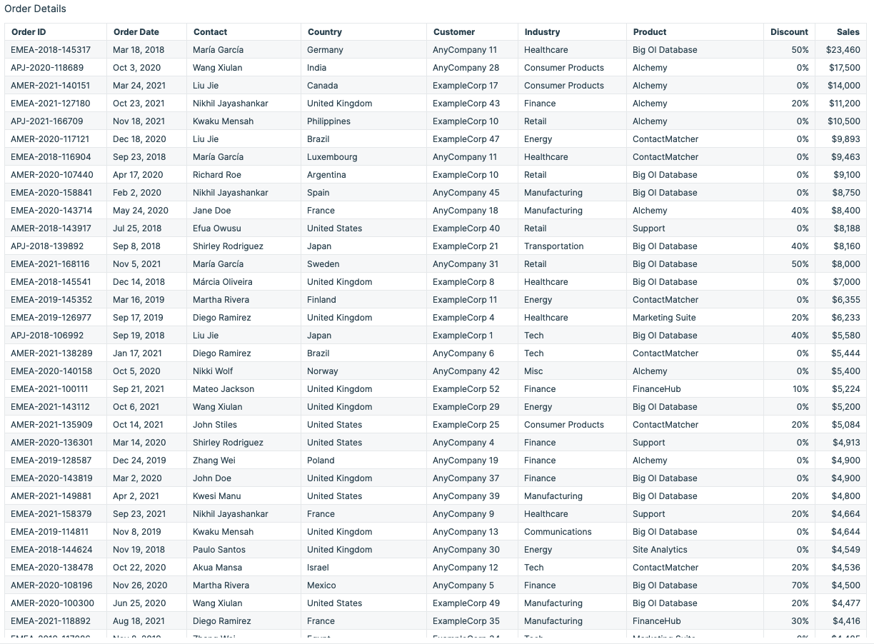

*Image description: The previous image shows the details table*.

TASK 4.3: APPLY CONDITIONAL FORMATTING TO A COLUMN

Apply conditional formatting on the Discount column to highlight which sales were completed at deep discounts (50% or higher) and which were within an acceptable range (under 50%).

1. In the menu bar at the top of the page, choose **Objects** and then choose **Conditional formatting**.

**Note:** You might need to select the table for Conditional formatting to be selectable.

1. In the **Conditional formatting** pane, under **Column**, choose **Select a column**.
2. Choose **Discount**.
3. Choose **Add background color**.
4. For **Fill type**, choose **Gradient**.
5. Choose the box next to **Max value**.
6. Choose **Custom color**.
7. In the **HEX** section, clear the current value and enter

.

1. Choose **Apply**.
2. For **Min value**, enter

.

1. For **Max value**, enter

.

1. Choose **Apply**.

**Expected output:** The Discount column now has conditional formatting that shows deep discounts in the darkest color, medium discounts in a lighter color, and low discounts in the lightest color. QuickSight offers flexible conditional formatting options to help visualize the stories you want to tell in each dashboard.

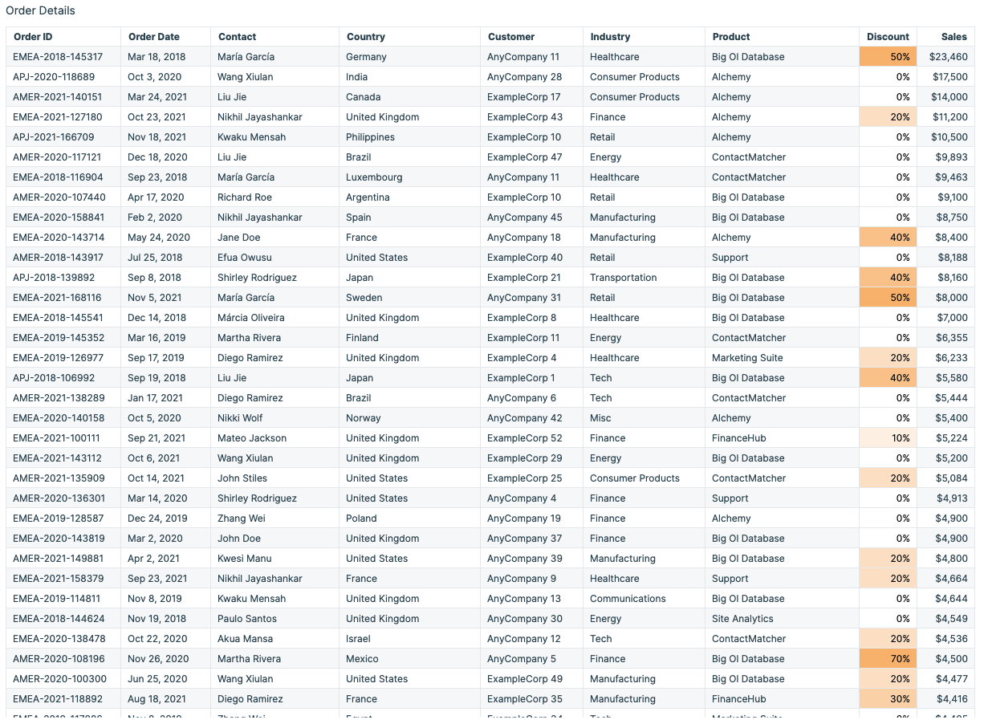

*Image description: The previous image shows the details table with gradient coloring*.

**Learn more:** For more information about conditional formatting in QuickSight, see [Adding Conditional Formatting to Visuals](https://docs.aws.amazon.com/quicksight/latest/user/conditional-formatting-for-visuals.html) in the *Amazon QuickSight User Guide*.

CHALLENGE A: APPLY CONDITIONAL FORMATTING TO ROWS

The product managers want a visual indicator of which orders occurred in 2021. Highlight the rows that represent sales in 2021 by using the conditional formatting menu. Use the **Order Date** field and color the rows blue.

**Hint:** Use **[Entire row]** when choosing a value from the **Column** list.

**Hint:** For help completing this challenge task, see the [**Challenge A solution**](https://us-east-1.durian.bkr.team.aws.training/session/snbSpPcXTYYqUWvGbJbhLq?locale=en-US&reference=sCm4f4gcixZqMUgXPoUz5y%3A%3A7759f935-0c5f-4c9f-a8d1-ce89471a7323#lab_2_challenge_a).

TASK 4.4: RENAME COLUMNS

Rename columns to clarify the results.

1. In the visualization menu on the right of your details table, choose the **Format visual** pencil icon to open the **Properties** menu.

**Note:** You might need to select the table to show the visualization menu on the right of your details table.

1. In the **Properties** pane, choose **Group-by column names**.
2. For **Contact Name**, enter

.

1. Choose **Group-by column names** again to collapse it, and then choose **Value column names**.
2. For **Discount (Average)**, enter

.

1. Choose **Value column names** again to collapse it.

**Task complete:** You have completed **Task 4** by creating a new sheet and adding conditional formatting to a table. You created a details sheet, added a table visualization, applied conditional formatting to columns and rows, and renamed columns.

**Task 5: Add a text comment using insights**

For the next quarterly meeting, the board wants the dashboard sent to the rest of the company. You want to include your contact information so that readers can reach out if they have any issues.

In this task, you edit a text insight to create a customized email contact link on the dashboard.

1. To navigate back to the main dashboard, in the dashboard workspace, choose the **Summary** tab.
2. In the navigation pane directly under the menu bar, choose the **Add Text** icon.
3. In the blank text box, enter



1. Highlight the text

 and choose the URL link icon on the top menu bar.

1. For **Enter link**, enter

.

1. Choose **Save** on the link box.
2. Resize the contact information and move it above your monthly sales line chart.

**Expected output:** Now, when your dashboard readers need to reach out, your contact information is readily available.

An image of the contact information visualization

*Image description: The previous image shows the contact information visualization*.

**Consider:** QuickSight offers customizable insights and autonarratives to condense written analysis and visualizations together. This capability helps you summarize large datasets quickly, include data dictionaries, and provide quick user actions such as an email contact. How could you use customizable insights at your company to communicate results and improve the user experience?

**Task complete:** You have completed **Task 5** by adding a text comment using insights. You added an insight and then customized it to address your specific needs.

**Task 6: Create a cascading filter**

Your team at AnyCompany Software wants to filter sales by region and subregion. You decide to add two filters to the dashboard. However, you want to make sure that when a region is selected, only the subregions for that region are provided as options.

In this task, you create a cascading filter that impacts the values presented in another filter.

TASK 6.1: ADD NEW FILTERS TO THE DASHBOARD

Add a region and subregion filter to the dashboard to increase interactivity so that readers can select the regions to analyze.

1. Choose any visualization on the dashboard.
2. In the navigation pane at the top of the page, choose **Filter**.
3. In the **Filters** pane, choose **+ ADD**.
4. Choose **Region**.
5. In the **Filters** pane, choose **Region** to expand the filter options.
6. To filter all of the visualizations on your dashboard at the same time, under **Edit filter**, choose **Only this visual**, and then choose **All applicable visuals**.
7. Choose **Apply**.
8. Choose the ellipsis icon next to the **Region** filter, and then choose **Add to sheet**.
9. To close the filter options, choose the arrow next to **Edit filter**.

**Expected output:** A region filter is now on the dashboard.

CHALLENGE B: CREATE A SUBREGION FILTER

Your team also needs to filter by subregion, depending on what kind of analysis they are doing. Add a filter for the **Subregion** field by using the same process you used for the **Region** filter.

**Hint:** For help completing this challenge task, see the [**Challenge B solution**](https://us-east-1.durian.bkr.team.aws.training/session/snbSpPcXTYYqUWvGbJbhLq?locale=en-US&reference=sCm4f4gcixZqMUgXPoUz5y%3A%3A7759f935-0c5f-4c9f-a8d1-ce89471a7323#lab_2_challenge_b).

TASK 6.2: ADJUST THE FILTER SETTINGS

Adjust the filter settings to show the correct subset of subregions for the region selected.

1. In the visualization menu on the right of your **Region** filter control, choose the pencil icon to open the **Format control** menu.
2. Choose **Control options**.
3. To open the options menu, choose **Dropdown - multiselect** and select **Dropdown**.
4. In the visualization menu on the right of your **Subregion** filter control, choose the pencil icon to open the **Format control** menu.
5. Choose **Show relevant values only**.
6. Choose **Region equals (Drop down)**.
7. Choose **Update**.

**Expected output:** Now, when you select a region, the values of the subregion control only show the subregions that belong to the region selected.

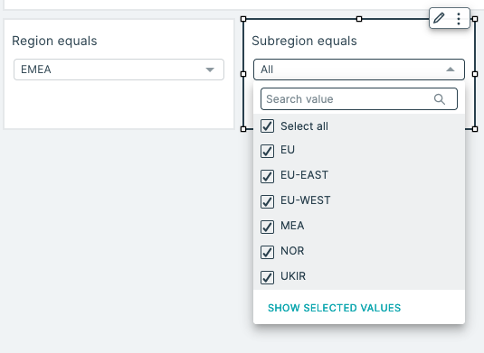

*Image description: The previous image shows the region and subregion filters being used*.

**Task complete:** You have completed **Task 6** by creating a cascading filter. You added region and subregion filters, and adjusted the subregion filter settings to only show relevant values.

**Task 7: Edit a filter action**

You want to add interactivity to the sales line chart when a month is selected.

In this task, you create a filter action with custom settings, limiting the filter action to prevalent visuals.

1. Choose the **Sum of Sales by Order Date** line chart visualization.
2. In the visualization menu to the right of the chart, choose the **Menu options** ellipsis icon and choose **Actions**.
3. In the **Actions** pane, choose **Filter same-sheet visuals**.

**Consider:** Take a moment to see what happens when you select a data point on the sales chart. Right now, when you select a data point, the **Forecast** and **Period over period** visualizations show errors.

1. Choose the arrow next to **Action 1**, and then choose **Edit**.
2. In the **Target visuals** pane, choose **Select visuals**.
3. Clear **Period over period** and **Forecast**.
4. Choose **Save**.

**Expected output:** Now, when you select a data point on the line chart, the **Forecast** and **Period over period** visualizations retain their data.

QuickSight offers this functionality so that you can create high levels of interactivity but still retain key performance indicators (KPIs) and forecasts in a static state if needed.

**Task complete:** You have completed **Task 7** by editing a filter action. You added an action to the sales line chart and tested that selections on the line chart update the correct visualizations.

**Task 8: Add cross-sheet functionality**

When the product managers are researching AnyCompany Software’s sales by industry, they want to be able to view the detailed table for the industry they are interested in. Instead of creating multiple tables, you want to set up a filter action in which managers can navigate to a filtered details table on another tab based on their selections on the summary dashboard.

In this task, you set up a navigation action to drill down to another sheet based on an industry selection on the main sheet.

TASK 8.1: CREATE A PARAMETER

Create a custom parameter for industry.

1. In the dashboard workspace, choose the **Details** tab to navigate to your **Order Details** table.
2. In the navigation pane at the top of the page, choose **Parameters**.
3. In the **Parameters** pane, choose **Create one…**.
4. For **Name**, enter

.

1. Choose **Create**.
2. Choose the **Custom actions** icon.
3. In the navigation pane at the top of the page, choose **Parameters**.
4. Choose the ellipsis icon next to **Industry**.
5. Choose **Add control**.
6. For **Name**, enter

.

1. Choose **Add**.

**Expected output:** You now have a custom parameter named *Industry* that you can interact with through the **Controls** menu above your table.

TASK 8.2: CREATE A FILTER BASED ON A PARAMETER

Create a filter on the details sheet based on the industry parameter.

1. On the **Details** sheet, choose the **Order Details** table if it is not already selected.
2. In the navigation pane at the top of the page, choose **Filter**.
3. In the **Filters** pane, choose **+ ADD**.
4. Choose **Industry** from the list.
5. Choose **Industry** to expand the filter options.
6. For **Filter type**, choose **Custom filter**.
7. Select **Use parameters** to enable parameter use.
8. To expand the filter to all visuals of this dataset, choose **Yes** on the pop-up window.
9. Choose **Select a parameter** to expand the parameter list, and then choose **Industry**.
10. Choose **Apply**.

**Expected output:** The parameter is now set up to filter the **Order Details** table.

TASK 8.3: CREATE A NEW ACTION

Create an action on the industry donut chart that navigates the reader to the details page.

1. To navigate back to the main dashboard, in the dashboard workspace, choose the **Summary** tab.
2. Choose the **Sales by Industry** donut chart.
3. In the visualization menu to the right of the donut chart, choose the **Menu options** ellipsis icon and choose **Actions**.
4. In the **Actions** pane, choose the **+ Add** icon.
5. For **Action name**, enter

.

**Note:** The <<Industry>> variable in the name acts as a field value variable that corresponds to the slice selected by the reader.

1. For **Action type**, choose **Navigation action**.
2. For **Target sheet**, choose **Details**.
3. Next to **Parameters**, choose the plus **+** icon.
4. For **Parameter**, choose **Industry**.
5. For **Set parameter value**, choose **Field: Industry**.
6. Choose **Add**.
7. Choose **Save**.

**Expected output:** You now have an action that navigates the reader to the details sheet.

1. **Refresh:** Refresh your webpage by choosing your browser’s  icon.
2. Open (right-click) the finance slice, and then choose the **See orders from Finance customers** option.

**Expected output:** The action moves the reader to the details page and filters for the **Finance** industry.

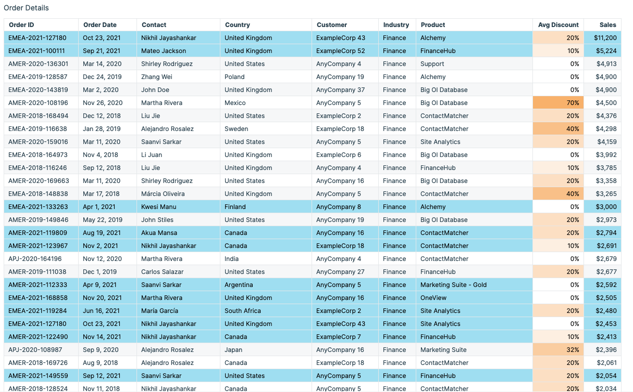

*Image description: The previous image shows the filtered details table*.

**Note:** If you want to reset the filter in the Industry column, above the dashboard workspace, choose the **Controls** section to expand it. Delete

. When you choose the table again, the field resets.

**Consider:** Take a moment to think about other ways you can add interactivity to the dashboard. How can you help multiple teams in your company gain valuable insights in the same sales dashboard? What other cross-sheet functionality can you add to help your readers dig deep into the data?

**Task complete:** You have completed **Task 8** by adding cross-sheet functionality. You created a parameter, added a filter based on a parameter, and implemented a cross-sheet action.

**Task 9: Implement URL actions**

You want to add URL actions that take users to an external webpage based on their selections. Eventually, you also want to add functionality that links users to internal Wiki content to guide their research and analytics.

In this task, you define a custom action that searches for a contact based on a table selection.

1. On the **Details** sheet, choose the **Order Details** table.
2. In the visualization menu to the right of the table choose the **Menu options** ellipsis icon and choose **Actions**.
3. In the **Actions** pane, choose **Define a custom action**.
4. For **Action Name**, enter

.

1. For **Activation**, choose **Menu option**.
2. For **Action Type**, choose **URL Action**.
3. For **URL**, enter

.

1. Choose **Save**.

**Expected output:** When you open (right-click) any row, you see a new option to search for the contact.

**Note:** You can open any URL and dynamically insert data values into it. You can use this capability to navigate to an internal or external search engine or take users to custom content.

CHALLENGE C: SEND AN EMAIL TO AN ACCOUNT OWNER BASED ON USER SELECTION

Set up another action that sends a custom email to the company contact.

**Hint:** To create the customized email, for **URL**, use

 and

.

**Hint:** To draft an email, include *mailto:* at the beginning of a URL. Use *?subject* for the email subject and *&body* for the email body in the URL.

**Hint:** For help completing this challenge task, see the [**Challenge C solution**](https://us-east-1.durian.bkr.team.aws.training/session/snbSpPcXTYYqUWvGbJbhLq?locale=en-US&reference=sCm4f4gcixZqMUgXPoUz5y%3A%3A7759f935-0c5f-4c9f-a8d1-ce89471a7323#lab_2_challenge_c).

**Task complete:** You have completed **Task 9** by implementing URL actions. You defined two custom actions to look up a contact and send an email based on your table selection.

**Conclusion**

**Task complete:** You have expanded the functionality of your dashboard. Your readers can now dive deeper into the data and navigate through the relevant results quickly. The following is what your dashboard might look like at this point.

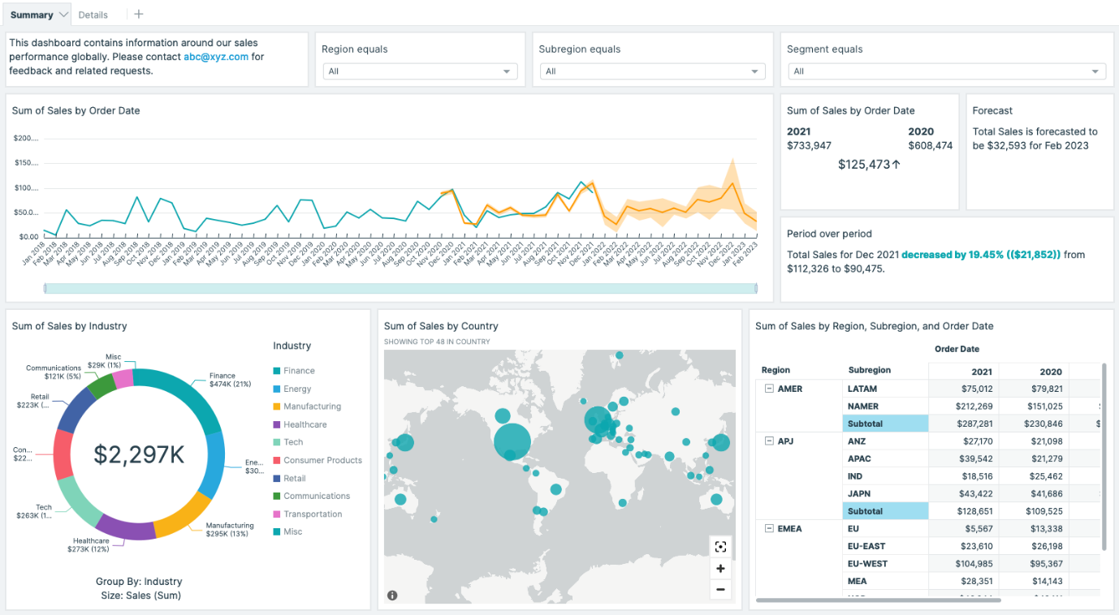

*Image description: The previous image shows the dashboard*.

You have successfully done the following:

* Created additional sheets for drilling down into data
* Established standardized themes for your organization
* Customized visuals and optimized dashboard layout settings
* Developed meaningful filter actions that simplify dashboard results
* Set up URL actions that link table results to web results

**End lab**

Follow these steps to close out the console and end your lab.

1. At the upper-right corner of the QuickSight console, choose the user icon and then choose **Sign out**.
2. On this screen, choose **End lab** and then confirm that you want to end your lab.

**Appendix**

CHALLENGE A SOLUTION

**Answer:** To complete this challenge, you create conditional formatting on rows, filtering for data that occurs on or after January 1, 2021.

1. In the visualization menu on the right of your details table, choose the ellipsis icon, and then choose **Conditional formatting**.
2. In the **Conditional formatting** pane, under **Column**, choose **Select a column**.
3. Choose **[Entire row]**.
4. Choose **Add background color**.
5. For **Format field based on**, choose **Order Date**.
6. For **Condition**, choose **After**.
7. For **Date**, enter

.

1. Select the box under **Color**.
2. Choose **Custom color**.
3. In the **HEX** section, clear the current value and enter

.

1. To close the pop-up, choose **Apply**.
2. To apply the changes, at the bottom left, choose **Apply**.

**Expected output:** All of the orders on or after 2021-01-01 are highlighted. The Discount conditional formatting is still applied on top of the highlighted rows.

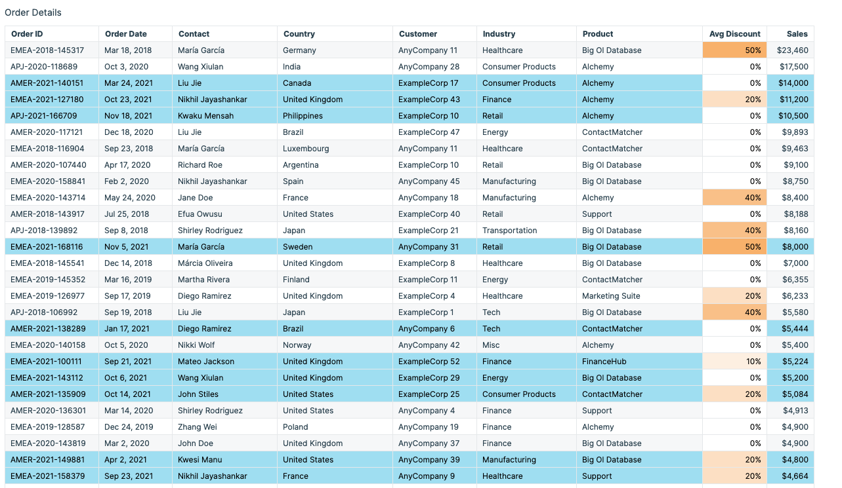

*Image description: The previous image shows the updated row formatting*.

To continue this lab, move on to [Task 4.4](https://us-east-1.durian.bkr.team.aws.training/session/snbSpPcXTYYqUWvGbJbhLq?locale=en-US&reference=sCm4f4gcixZqMUgXPoUz5y%3A%3A7759f935-0c5f-4c9f-a8d1-ce89471a7323#lab_2_task4-continue).

CHALLENGE B SOLUTION

**Answer:** To complete this challenge, you create a new subregion filter by using the same process as you used for the region filter.

1. Choose any visualization on the dashboard.
2. In the **Filters** pane, choose **+ ADD**.
3. Choose **Subregion**.
4. In the **Filters** pane, choose **Subregion** to expand the filter options.
5. To filter all of the visualizations on your dashboard at the same time, under **Edit filter**, choose **Only this visual**, and then choose **All applicable visuals**.
6. Choose **Apply**.
7. Next to the **Subregion** filter, choose the ellipsis icon and then choose **Add to sheet**.
8. To close the filter options, choose the arrow next to **Edit filter**.

**Expected output:** You now have two new filters on the dashboard. Your users can filter by region and subregion as needed.

To continue this lab, move on to the [Task 6.2](https://us-east-1.durian.bkr.team.aws.training/session/snbSpPcXTYYqUWvGbJbhLq?locale=en-US&reference=sCm4f4gcixZqMUgXPoUz5y%3A%3A7759f935-0c5f-4c9f-a8d1-ce89471a7323#lab_2_task6-continue).

CHALLENGE C SOLUTION

**Answer:** To complete this challenge, you add a new URL action that sends an email to the contact selected by the user.

1. On the **Details** sheet, choose the **Order Details** table.
2. In the visualization menu to the right of the table choose the **Menu options** ellipsis icon and choose **Actions**.
3. In the **Actions** pane, choose the plus **+** icon to create a new action.
4. For **Action Name**, enter

.

1. For **Activation**, choose **Menu option**.
2. For **Action Type**, choose **URL Action**.
3. For **URL**, enter

.

1. Choose **Save**.

**Expected output:** When you choose any row with a right click, you see a new option to email the contact.

To continue this lab, move on to the [Conclusion](https://us-east-1.durian.bkr.team.aws.training/session/snbSpPcXTYYqUWvGbJbhLq?locale=en-US&reference=sCm4f4gcixZqMUgXPoUz5y%3A%3A7759f935-0c5f-4c9f-a8d1-ce89471a7323#lab_2_conclusion-continue).